Procedure

Part 1: Introduction to MBED environment

1.1: Blinking LED
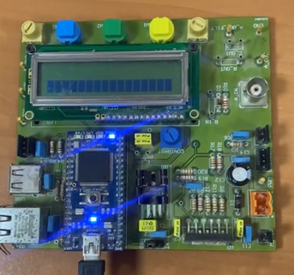
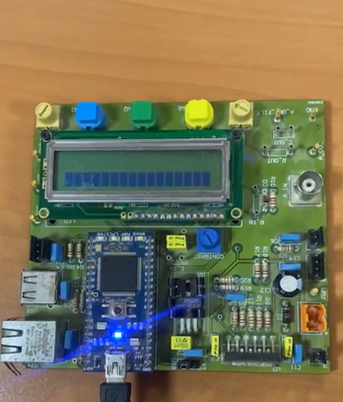
This part of the experiment demonstrates how to create a simple program using Mbed to make an LED blink. The code, provided in the appendix, is designed to control the built-in LED (LED1) on the Mbed board. The main function runs in an infinite loop, turning LED1 on and off with a 0.5-second delay between each state. This creates a continuous blinking effect, as shown in the figures X,Y below.

Figure 1: Blinking LED
The code creates a digital output object named "led," which is connected to the onboard LED1 pin of the microcontroller, for the purpose of controlling the LED. The `while(true)` loop runs the code inside it continuously in order to keep the led blinking. Turn the LED on by setting its state high (1), and keep it for 0.5 seconds; then turn it off by setting it to low (0) and keep it for another 0.5 seconds.
Task1: Write a code to make the four leds switch on one after the other. First LED1 is on for 0.2s, then LED2 is on for 0.2s, then LED3 is on for 0.2s ...
This is a task to light four LEDs one by one in a cascading effect. The code lights LED1 for 0.2 seconds and turns it off, then turns LED2 on for the same amount of time and turns it off as it turns LED3 on, then LED4. Each of these LEDs keeps turn on for 0.2 seconds before the next LED lights up as in Figure X. It then just loops to make a smooth continuous pattern.
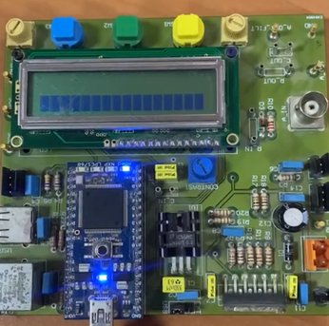
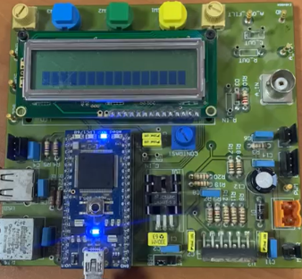
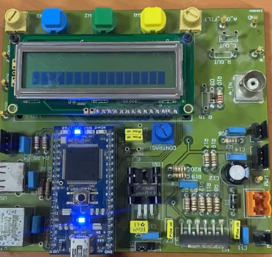
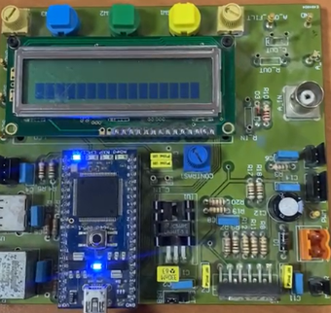
Figure 3: Sequential LED Blinking

Figure 2: Sequential LED Blinking

1.2: LCD Display
This part involves using the Mbed microcontroller to control an LCD for displaying text. The code creates an object called "lcd" and specifies SPI pins for communication along with two control pins. Inside an infinite while(1) loop, the LCD cursor is positioned at column 3, row 3 using lcd.locate(3, 3). The message "Write your message" is then displayed with lcd.printf(), and the screen is cleared afterward using lcd.cls().
We're really sorry, but we accidentally forgot to take a picture of this part, even though we did complete it and displayed our names on the LCD. We hope you can understand!

Conclusion
This experiment provided a clear understanding of the MBED microcontroller and its functionality with the ARM Mbed OS simulator. The MBED platform was explored by comparing it to Arduino to highlight key differences. Focus was placed on the hardware, particularly the number and functionality of its pins. Through practical examples on the simulator, the use of features such as ADC and DAC was demonstrated, along with MBED's ability to handle communication protocols like I2C. The experiment showcased MBED's capabilities in real-time applications and its role in fostering innovation and hands-on learning in technology and engineering.

Appendixes

Part 1:

1.1: Blinking LED

#include "mbed.h"
int main()
{
// Initialise the digital pin LED1 as an output
DigitalOut led(LED1);
while (true) {
led = 1; // turn led on
wait(0.5); // wait for 0.5 sec
led = 0;
wait(0.5);
}
}

Task1:
#include "mbed.h"

BusOut leds(LED1, LED2, LED3, LED4);

int main()
{
while (true) {

leds = 1;
wait(0.2);

leds = 2;
wait(0.2);

leds = 4;
wait(0.2);

leds = 8;
wait(0.2);
}
}

1.2: LCD Display

#include "mbed.h"
#include "TextLCD.h"

Serial pc(USBTX, USBRX); // tx, rx
TextLCD lcd(p28, p27, p26, p25, p24, p23);// rs, e, d4-d7

int main() {
pc.baud(115200);
// send string from mbed to PC
pc.printf("Hello World!\n");
while(1) {
if (pc.readable()){ // check if there is any data
char c = pc.getc(); // read data
if (c == '0'){
lcd.printf("Write your message");
}
else if (c == '1'){
lcd.printf("this is Lana");
}
else if (c == '2'){
lcd.printf("this is Aya");
}
else if (c == '3'){
lcd.printf("this is Yasoomi");
}
}
}
}

